
.
FOURTH SUNDAY OF LENT  MARCH 11, 2018


Sat. Mar. 10 VIGIL-FOURTH SUNDAY OF LENT
4:00pm Mary Lou Moritz by Mary Knowles

Sun. Mar. 11 FOURTH SUNDAY OF LENT
8:30am Vincent Chiodo by Dr. & Mrs. Ed Yanulavich
9:45am For the People of the Parish

Mon. Mar. 12 LENTEN WEEKDAY
8:30am Communion Service & Novena of the Miraculous Medal

Thurs. Mar. 15 LENTEN WEEKDAY
8:30am Communion Service & Rosary

Fri. Mar. 16 LENTEN WEEKDAY
5:30pm Simple Supper-Soup and Bread
6:30pm Stations of the Cross and Communion Service

Sat. Mar. 17 VIGIL-FIFTH SUNDAY OF LENT
4:00pm For the People of the Parish

Sun. Mar. 18 FIFTH SUNDAY OF LENT
8:30am Olga Lipsie by M/M Stephen Proch
9:45am Elden Nawrocki by Lyn & Rob Giordano

Please pray for the repose of the souls of
Germaine Mazurik and Carmen Nordstrom
who died this past week.
Eternal rest grant unto them, O Lord
and let Perpetual Light shine upon them.
And may the souls of all the faithful departed,
Through the mercy of God, rest in Peace. Amen


Parishioners who are sick and in need
of prayers can be added to our prayer
list by calling the Parish Office at
570-842-4995. Please pray for:
P.J. Cappola, Helen Zerbe, Paula Peet,
Carmel Ann Maxson, Nicholas Pierotti, Susan Golombos, Joseph Falchek, Donna Jean Marabella, Jeanne Tierney, Pete Tambasco, Arline Chumacas, Jenny Filingo, Jerry White, Jennifer Simis, Alan Lemech, Vincent Orazi, Ben Topar, Bob Jantz, Phyllis Braun, Richard Major, Vonette Castelblanco, Bill Vockroth, Jane Colwell, Jeanne Kopyta, Muriel Calame, Jamie Jantz, Donna Lewis, Jason Scott Taylor, Joanne Arredondo, Vincent Natoli and all the sick of the Parish.

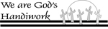

Laetare Sunday
The fourth Sunday in Lent
The fourth Sunday in Lent (Mid-Lent) derives its Latin name from the first word of the Mass text, "Laetare Jerusalem" (Rejoice, O Jerusalem). It is a day of joy within the mourning season. The altars may be decorated with flowers, organ playing is permitted, and the priests may wear rose-colored vestments instead of purple. The reason for such display of joy is explained in a sermon by Pope Innocent III (1216):
"On this Sunday, which marks the middle of Lent, a measure of consoling relaxation is provided, so that the faithful may not break down under the severe strain of Lenten fast but may continue to bear the restrictions with a refreshed and easier heart."[31]
As a symbol of this joy the popes used to carry a golden rose in their right hand when returning from the celebration of Mass. Pope Leo IX (1051) calls this custom an "ancient institution." Originally it was a single rose of natural size, but since the fifteenth century it has consisted of a cluster or branch of roses wrought of pure gold and set with precious stones in brilliant workmanship by famous artists. The popes bless it every year, and often they confer it upon churches, shrines, cities, or distinguished persons as a token of esteem and paternal affection. In case of such a bestowal, a new rose is made during the subsequent year. The meaning and symbolism of the golden rose is expressed in the prayer of blessing. It represents Christ in the shining splendor of His majesty, the "flower sprung from the root of Jesse." From this ecclesiastical custom Laetare Sunday acquired its German name, Rosensonntag (Sunday of the Rose).
In this country Laetare Sunday receives much publicity in the papers because of Notre Dame's bestowal each year (since 1883) of the Laetare Medal on an American lay Catholic distinguished in literature, art, science, philanthropy, sociology, or other field of achievement. It is an adaptation of the papal custom of the golden rose, and the medal is made of heavy gold and black enamel tracings bearing the inscription "Magna est veritas et praevalebit" (Truth is mighty and shall prevail). It is suspended from a bar on which is lettered "Laetare Medal."

Our Pilgrim Statue of the Blessed Virgin Mary

If she has not yet visited your home and you would like information or to sign up to have the Statue visit your home, please call Pat Manago at 570-848-2284.
This is where the statue will be traveling in the
weeks to come: 3/11-Nawrocki Family 3/18-Nawrocki Family
3/25-Nawrocki Family 4/01-Natoli Family
4/08-Natoli Family 4/15-OPEN

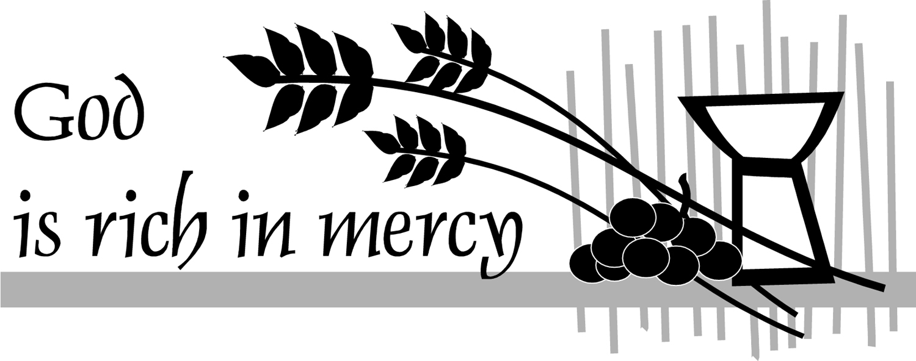
Mar. 11, 2018 FOURTH SUNDAY OF LENT
LECTORS:
Mar. 10^{Tth} 4:00pm Lyne Van Houtte
Mar. 11th 8::30am Pat Manago
9:45am Children
EXTRAORDINARY MINISTERS OF THE EUCHARIST:
Mar. 10th 4:00pm R. Natoli/L. Van Houtte
Mar. 11th 8:30am T. Butel/J. Martino
9:45am T. Butel/K. Fossetta
ALTAR SERVERS:
Mar. 10th 4:00pm Alan Hynes
Mar. 11th 8:30am Susan Pilosi

9:45am Sharon Lenzer/Ayden Hull
HOSPITALITY & USHERS:
Mar. 10th 4:00pm Andy Kelemen/Victor Benfatti
Mar. 11th 8:30am Tom Volpe/Richard Colwell
9:45am Tom Quinn/Richard Erazmus
Mar. 18, 2018 FIFTH SUNDAY OF LENT
LECTORS:
Mar. 17^{Tth} 4:00pm Lyne Van Houtte
Mar. 18th 8::30am Richard Colwell
9:45am Daria Killian
EXTRAORDINARY MINISTERS OF THE EUCHARIST:
Mar. 17th 4:00pm T. Butel/M. Rounsavill
Mar. 18th 8:30am S. Pilosi/A. Proch
9:45am K. Fossetta/M. Croak
ALTAR SERVERS:
Mar. 17th 4:00pm Alan Hynes
Mar. 18th 8:30am Veronica Yanulavich
9:45am S. Lenzer/A. Hull
HOSPITALITY & USHERS:
Mar. 17th 4:00pm Andy Kelemen/Victor Benfatti
Mar. 18th 8:30am Ed Snyder/Tom Volpe
9:45am Frank Kopyta/Tom Quinn

STEWARDSHIP OF TREASURE:


3/04/18
ENVELOPES (32): $ 945.00
LOOSE: $ 102.00
SCHOOL DEBT (10): $ 69.00
FREE WILL OFFERING: $ 140.00
TOTAL: $ 1256.00

DIOCESAN COLLECTION:
RICE BOWL (2): $ 55.00
CARE & EDUCATION(12) $ 76.00

03/04 02/25 02/18 02/11
PEOPLE ATTENDING: 4:00PM 12 55 90 45
8:30AM 34 34 33 51
9:45AM 27 69 34 58

THANK YOU FOR YOUR GENEROSITY!

OUR BUS TRIP WAS POSTPONED UNTIL MONDAY, MARCH 19 TO THE SANDS CASINO! WE STILL HAVE A FEW SEATS LEFT!
Cost is $25.00
Rebates: $20/slots
$5/food
Payment must be made with reservation.
To register call Mary at 570-676-3711 or the Parish Office at 570-842-4995.

GOOD FRIDAY COLLECTION
FOR THE HOLY LAND
The Good Friday collection helps to supports the work of the Franciscans who care for the Holy Places as well as the Christians living in the Holy Land. It is vital that we care for the Christians living there in order to maintain a Christian presence in a land filled with a majority Islamic and Jewish population. When you contribute you stand in solidarity with the Church in the Holy Land as a witness of peace, supporting parishes and schools, maintaining Christian shrines and caring for refugees in the Holy Land. Please be generous!

9-DAY BEST OF BRITAIN TOUR
September 15-24, 2018
$3,195.00 pp. dbl. occ.
Windso-Oxford-Edinburgh-Liverpool-Cardiff-Stonehenge & London
Book by 3/15/18 & Save $100 pp.
LED BY FATHER KEVIN MULHERN
Deposit $250.00pp
Final Payment due July 31, 2018
Contact TRAVELWORLD
570-342-5790/800-828-6029
www.asktravelworld.com. For complete itinerary and reservations.

PENANCE SERVICE
POSTPONED DUE TO WEATHER
UNTIL MARCH 23, 2018

PASTORAL COUNCIL MEETING
MONDAY, MARCH 19 AT 6:30PM

